

Practices for Secure Software Report

Table of Contents
Document Revision History 3
Client 3
Instructions 3
Developer 4
1. Algorithm Cipher 4
2. Certificate Generation 4
3. Deploy Cipher 4
4. Secure Communications 4
5. Secondary Testing 4
6. Functional Testing 4
7. Summary 4
8. Industry Standard Best Practices 4

Document Revision History

Version | Date | Author | Comments
1.0 | 10/18/2026 | Arvin Agas

Client



Instructions

Submit this completed practices for secure software report. Replace the bracketed text with the relevant information. You must document your process for writing secure communications and refactoring code that complies with software security testing protocols.

- Respond to the steps outlined below and include your findings.
- Respond using your own words. You may also choose to include images or supporting materials. If you include them, make certain to insert them in all the relevant locations in the document.
- Refer to the Project Two Guidelines and Rubric for more detailed instructions about each section of the template.

Developer
Arvin Agas

Algorithm Cipher

Based on Artemis Financial’s requirement of adding a file verification step via checksum, the recommended algorithm cipher to use is the Secure Hash Algorithm-2 (SHA-2), more specifically the 256-bit variant.

SHA-256 is a cryptographic function designed to create unique hash values based on the original input. Like its predecessor, the deprecated SHA-1, SHA-2 variants take the given text and transform it into hashed content consisting of hexadecimal characters, a process that leverages mathematical operations that pad the original message and becomes impossible to reverse engineer.

The switch to SHA-2 family algorithms in modern times is due to the increasing requirement of cyber security. SHA-1 has up to 2^160 possible combinations for a hashed message. While SHA-1 did its job well when it was first implemented in the 1990s, computing power was not as plentiful back then. However, a SHA-1 exploit that utilized collisions, or events when two unique inputs create the same hash text, allowed the possibility of switching a verified file with a malicious one, showcasing the exploit potential of SHA-1. Whereas SHA-1 produced a 160-bit hash, the recommended SHA-256 function creates a much larger 256-bit hash, reducing the chance of a collision occurring to practically zero. Because of the larger hash size that is created by SHA-256, it becomes harder for bad actors to fake the correct signature as there are 2^256 combinations that must be accounted for, an amount that is impossible to filter through with today’s technology.

While there are other variants within the SHA-2 family, including SHA-224, SHA-384, and SHA-512, SHA-256 is the industry standard when using a published checksum to verify the authenticity of a downloaded file due to its balanced collision resistance and resource consumption.

Certificate Generation
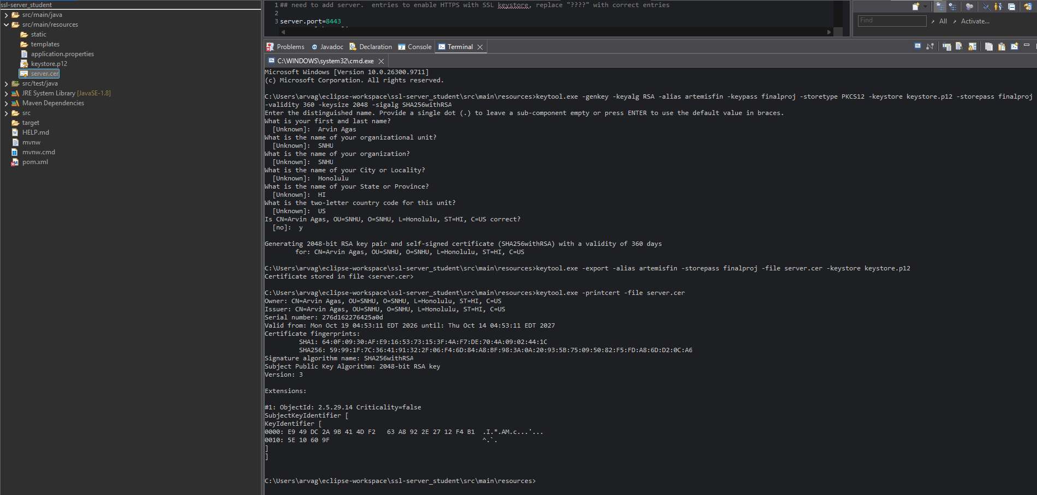

Deploy Cipher
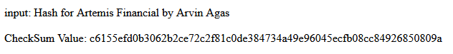

Secure Communications
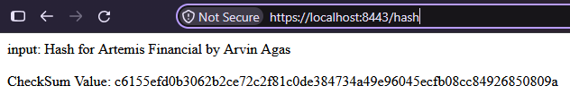
Because a self-signed certificate is used, it’s unverified by trusted Certificate Authorities. However, SSL is enabled, allowing access to the endpoint through the HTTPS protocol.

Secondary Testing
Insert screenshots below of the refactored code executed without errors and the dependency-check report.

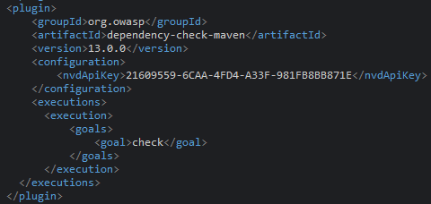
Latest version of the dependency check tool located within pom.xml

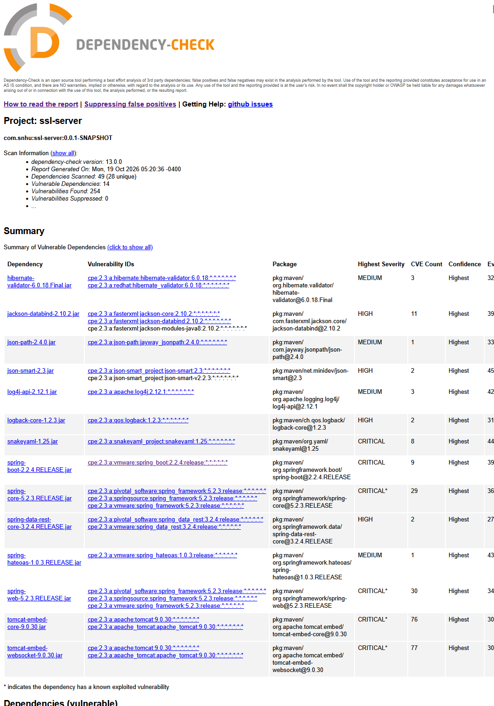

Functional Testing
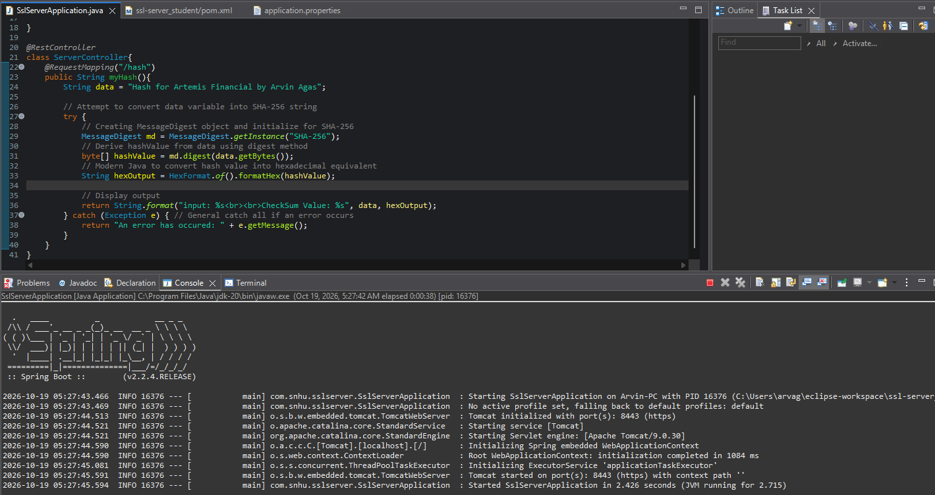
Functional “/hash” endpoint with successful launch of web server.

Summary
In refactoring the given code presented by Artemis Financial, several areas of security were addressed after a comprehensive architecture review. To satisfy the company’s requirements, the recommended SHA-256 algorithm was implemented to verify integrity when downloading files. This ensures that retrieved data has not been tampered with. Additionally, a self-signed certificate was generated to modify the web server requests to be handled securely using HTTPS protocol as opposed to the unsecure HTTP variant. This change allows data transmission between client devices and to the server to be encrypted. Finally, the OWASP Dependency-Check tool was updated to its latest version. This plugin permitted the team to identify publicly disclosed vulnerabilities, allowing for faster bug patching and innovating code that is more resilient and secure.

Industry Standard Best Practices
The changes implemented to the given codebase follow the standard industry practices in multiple ways. The suggested SHA-256 algorithm aligns with the guidelines set forth by the National Institute of Standards and Technology, and its balanced collision resistance and resource consumption is the de facto cryptographic hash function that is used online. In efforts to secure communication and encrypt data, the program enforces the use of a security certificate to access endpoints via the HTTPS protocol instead of the plain HTTP. If a certificate signing request was submitted to an authorized Certificate Authority and approved, web browsers would view the web program as trustworthy and secure. Finally, the integration of the OWASP Dependency-Check tool allows project dependencies to be checked against the National Vulnerability Database. Its ability to synchronize to a database that constantly updates common vulnerabilities and exposures is an invaluable asset to improving response timings concerning program security.

For a company that has access to highly sensitive data, following best security practices is a requirement. Flawed code and unencrypted access points increase financial risk and customer information leakage, hurt brand image, and severely raises the technical debt that must be addressed. Adhering to the industry standards and careful security planning from the beginning allows organizations to be compliant with regulations, more resilient to cyber-attacks, protects their reputation, and safeguards client information.

